CMS for Schools 2015

- After logging in, choose “Update My Profile” and fill in the blanks. You should upload a school picture if you have access to one. Under “Profile,” add your required information. You may simply type the information or put it into a table first.
  - Name, school phone, school email and job title
  - Photo—please use a school setting picture such as your ID badge picture
  - Degrees and educational experience/background
  - Professional memberships, service to the organizations-offices held, etc. – Sell yourself as a professional.
  - Extra Curricular Assignments
  - A short narrative about teacher’s interests, family, or interesting tidbit or quote can be used but is not required.
- If you click on “My Home Page,” the navigation builder page will be displayed. Click on “Add Page,” to add pages to your web site. These will display on the left side of your page under your home page link. You will need to create the following:
  - Schedule for High School
Period | A Lunch |  | Period | B Lunch |  | Period | Early Release
1 | 8:03-8:51 |  | 1 | 8:03-8:51 |  | 1 | 8:03-8:38
2 | 8:55-9:43 |  | 2 | 8:55-9:43 |  | 3 | 8:42-9:43
3 | 9:47-11:15 |  | 3 | 9:47-11:15 |  | 4 | 9:47-10:48
Lunch | 11:15-11:45 |  | 4 | 11:19-12:44 |  | 2 | 10:52-11:22
4 | 11:48-1:13 |  | Lunch | 12:44-1:14 |  | Lunch A | 10:52-11:22
ELT | 1:17-1:48 |  | ELT | 1:17-1:48 |  | Lunch B | 11:26–11:56
6 | 1:52-3:20 |  | 6 | 1:52-3:20 |  | 6 | 12:00-1:05
Middle School
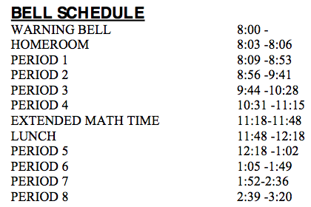
  - Course descriptions/Syllabus page
  - Link to Family Access
    - https://sdobweb.bonduel.k12.wi.us/scripts/cgiip.exe/WService=wsSky/seplog01.w
  - Any other professional content that you want to add to your web page.
- Building a Page (After you Add a Page)
  - Give your page a name
  - Choose internal link and active
  - Navigation order puts the page in the order that you want your links to exist on the left side of the page
  - Select level 1
  - To add information to the page, go to Navigation Builder (My Home Page,) choose “Main Body” for that page, and at the bottom of the page, choose “Update Text/Graphic Editor.”
  - Type your information.
- Upload a File
  - If you want to upload a file (like a syllabus,) click on “My File Uploads” and choose the number of files that you want to upload.
  - Once you have uploaded your files, you will see them listed. If you click on the “i” next to the document, it will give you a web address for your document.
  - Type the name of the document on the page (example: on my course description page, I would type “UWGB Eng Comp Syllabus”) and highlight the words. Then choose the link icon and paste the web address in the blank. When you update the page, the words should link to your document.
- If you want a web page that is more creative, you can put your information into a WIX or WEEBLY web page and link it to your school page. There is a handout on how to use Weebly on my web page under tech handouts.

